THE GREAT INVITATION IS HAPPENING
“The kingdom of heaven may be
compared to a King who gave a Wedding Feast for his Son, and sent his servants to call those who were invited to the Wedding Feast, but they would not come… Then he said to his servants, ‘The Wedding Feast is ready, but those invited were not worthy…
Go therefore to the highways and invite to the Wedding Feast as many as you find.’ And those servants went out into the roads and gathered all whom they found, both bad and good. So the wedding hall was filled with guests!
Matthew 22
www.TheGreatInvitation.net

You areCordially Invited
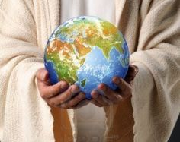
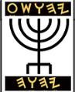
To Attend &Celebrate …

www.TheGreatInvitation.net
THE GREAT INVITATION IS HAPPENING
“The kingdom of heaven may be
compared to a King who gave a
Wedding Feast for his Son, and sent his servants to call those who were invited to the Wedding Feast, but they would not come… Then he said to his servants, ‘The Wedding Feast is ready, but those invited were not worthy…
Go therefore to the highways and invite to the Wedding Feast as many as you find.’ And those servants went out into the roads and gathered all whom they found, both bad and good. So the wedding hall was filled with guests!
Matthew 22
www.TheGreatInvitation.net

You areCordially Invited
To Attend &Celebrate …

www.TheGreatInvitation.net
THE GREAT INVITATION IS HAPPENING
“The kingdom of heaven may be
compared to a King who gave a Wedding Feast for his Son, and sent his servants to call those who were invited to the Wedding Feast, but they would not come… Then he said to his servants, ‘The Wedding Feast is ready, but those invited were not worthy…
Go therefore to the highways and invite to the Wedding Feast as many as you find.’ And those servants went out into the roads and gathered all whom they found, both bad and good. So the wedding hall was filled with guests!
Matthew 22
www.TheGreatInvitation.net

You areCordially Invited
To Attend &Celebrate …

www.TheGreatInvitation.net

The 7-Day Wedding Feast
Of the Lamb of Yahweh –
The Prince of Peace &
The King of kings:
Yahsha the Messiah
&
His Resurrected Bride
Time: Commencing Sunset Sept.26, 2026
Occasion: The Hebrew Feast of Tabernacles
Place: The Temple Mount - Jerusalem
Israel Earth (Don’t forget to RSVP!)

Once again, He will turn water into wine!

All Mankind may Download the FREE eBook
Or Go to AMAZON.com for what
The BRIDE has been waiting for…
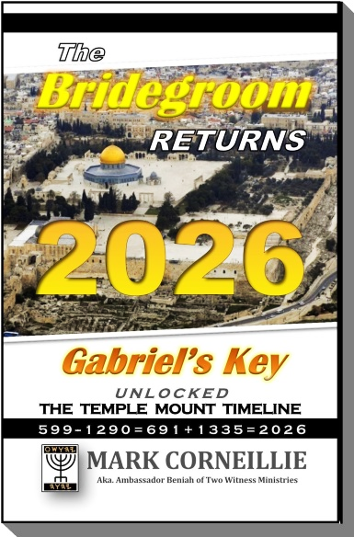
THE
BRIDEGROOM
RETURNS
2 0 2 6 –
Gabriel’s Key
Unlocked
The Temple Mt
Timeline
*************
180 page Book
of Last Days
Revelation &
Great News!!
Learn what the Prophet Daniel didn’t know-
That which was SEALED is now REVEALED

The 7-Day Wedding Feast
Of the Lamb of Yahweh –
The Prince of Peace &
The King of kings:
Yahsha the Messiah
&
His ResurrectedBride
Time: Commencing Sunset Sept.26, 2026
Occasion: The Hebrew Feast of Tabernacles
Place: The Temple Mount, Jerusalem
Israel Earth (Don’t forget to RSVP!)

Once again, He will turn water into wine!

All Mankind may Download the FREE eBook
Or Go to AMAZON.com for what
The BRIDE has been waiting for…
THE
BRIDEGROOM
RETURNS
2 0 2 6 –
Gabriel’s Key
Unlocked
The Temple Mt
Timeline
*************
180 page Book
of Last Days
Revelation &
Great News!!
Learn what the Prophet Daniel didn’t know-
That which was SEALED is now REVEALED

The 7-Day Wedding Feast
Of the Lamb of Yahweh –
The Prince of Peace &
The King of kings:
Yahsha the Messiah
&
His ResurrectedBride
Time: Commencing Sunset Sept.26, 2026
Occasion: The Hebrew Feast of Tabernacles
Place: The Temple Mount, Jerusalem
Israel Earth (Don’t forget to RSVP!)

Once again, He will turn water into wine!

All Mankind may Download the FREE eBook
Or Go to AMAZON.com for what
The BRIDE has been waiting for…
THE
BRIDEGROOM
RETURNS
2 0 2 6 –
Gabriel’s Key
Unlocked
The Temple Mt
Timeline
*************
180 page Book
of Last Days
Revelation &
Great News!!
Learn what the Prophet Daniel didn’t know.
That which was SEALED is now REVEALED

